CS 3305-01 Web Programming 2

Instructor: Professor Jim Casale

Name: Anonymos

Programming Assignment Unit 3

**Section 1: Introduction**

I have completed section 1 ‘Introduction’.

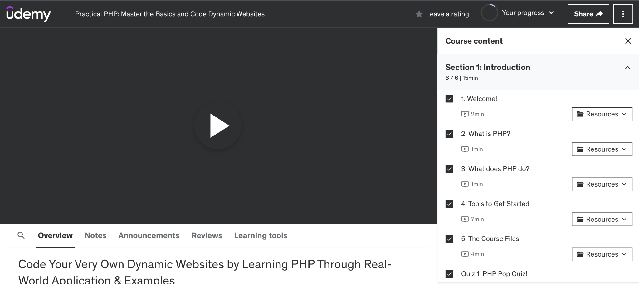

Figure 1. A screenshot showing that section 1 ‘Introduction’ has been completed.

**Section 2: PHP Basics**

I have completed section 2 ‘PHP Basics’.

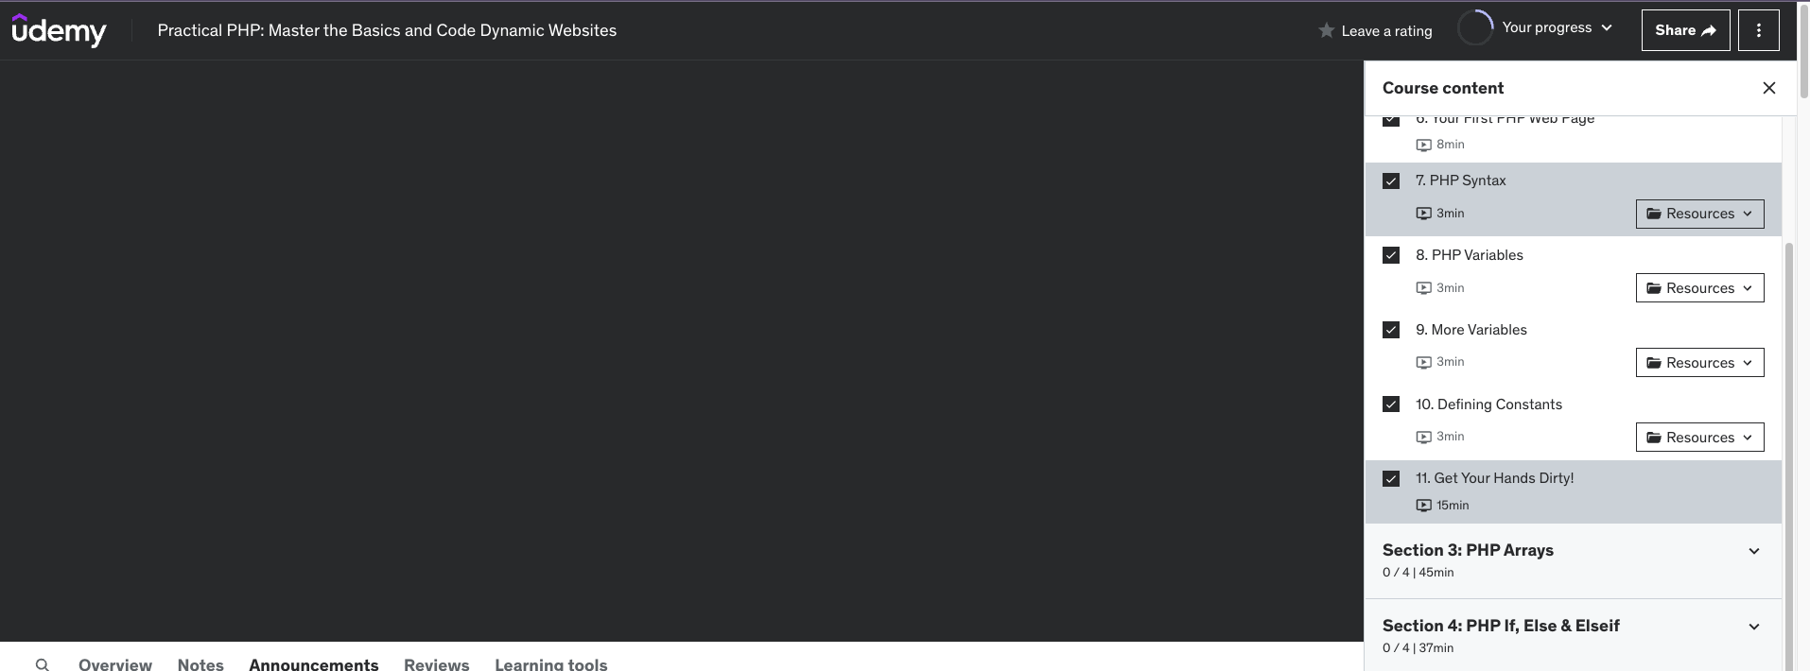

Figure 2-1. A screenshot showing that section 2 ‘PHP Basics’ has been completed.

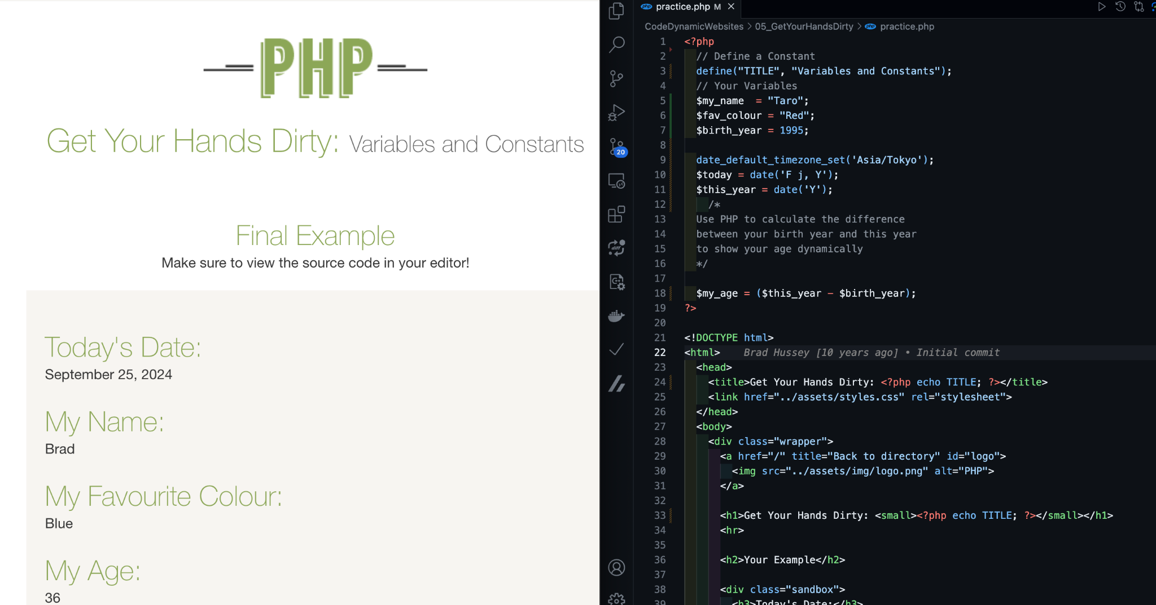

Figure 2-1. A screenshot showing that section 2 ‘PHP Basics’ has been completed.

**Section 3: PHP Arrays**

I have completed section 3 ‘PHP Arrays’.

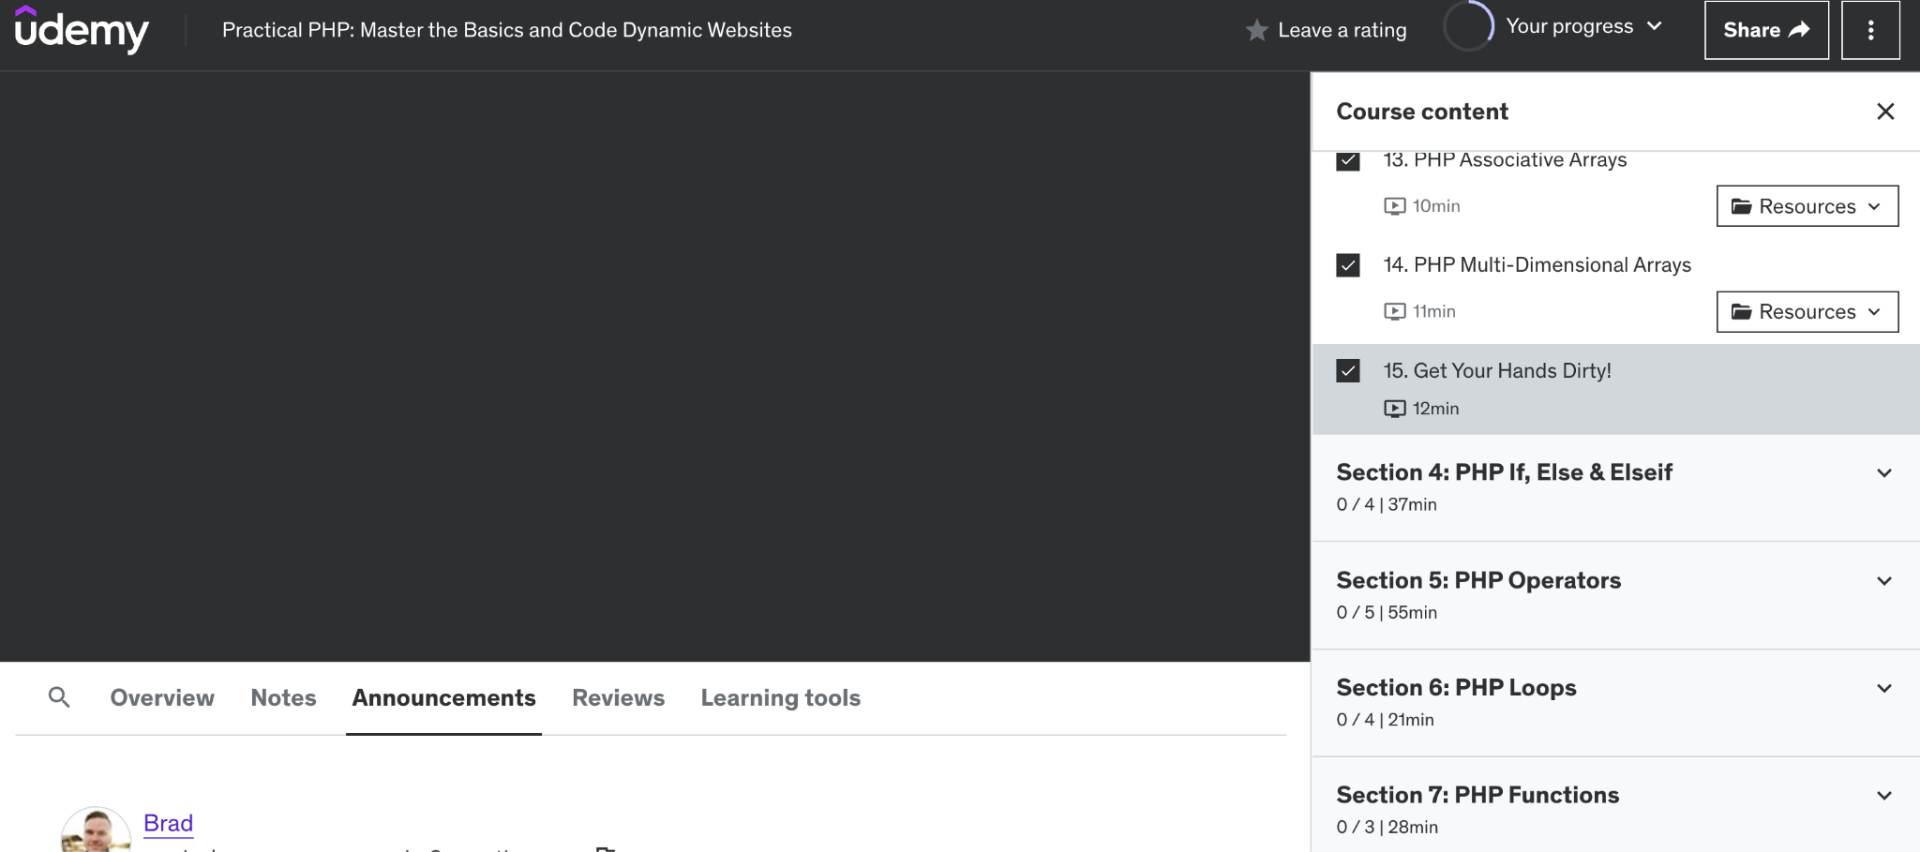

Figure 3-1. A screenshot showing that section 3 ‘PHP Arrays’ has been completed.

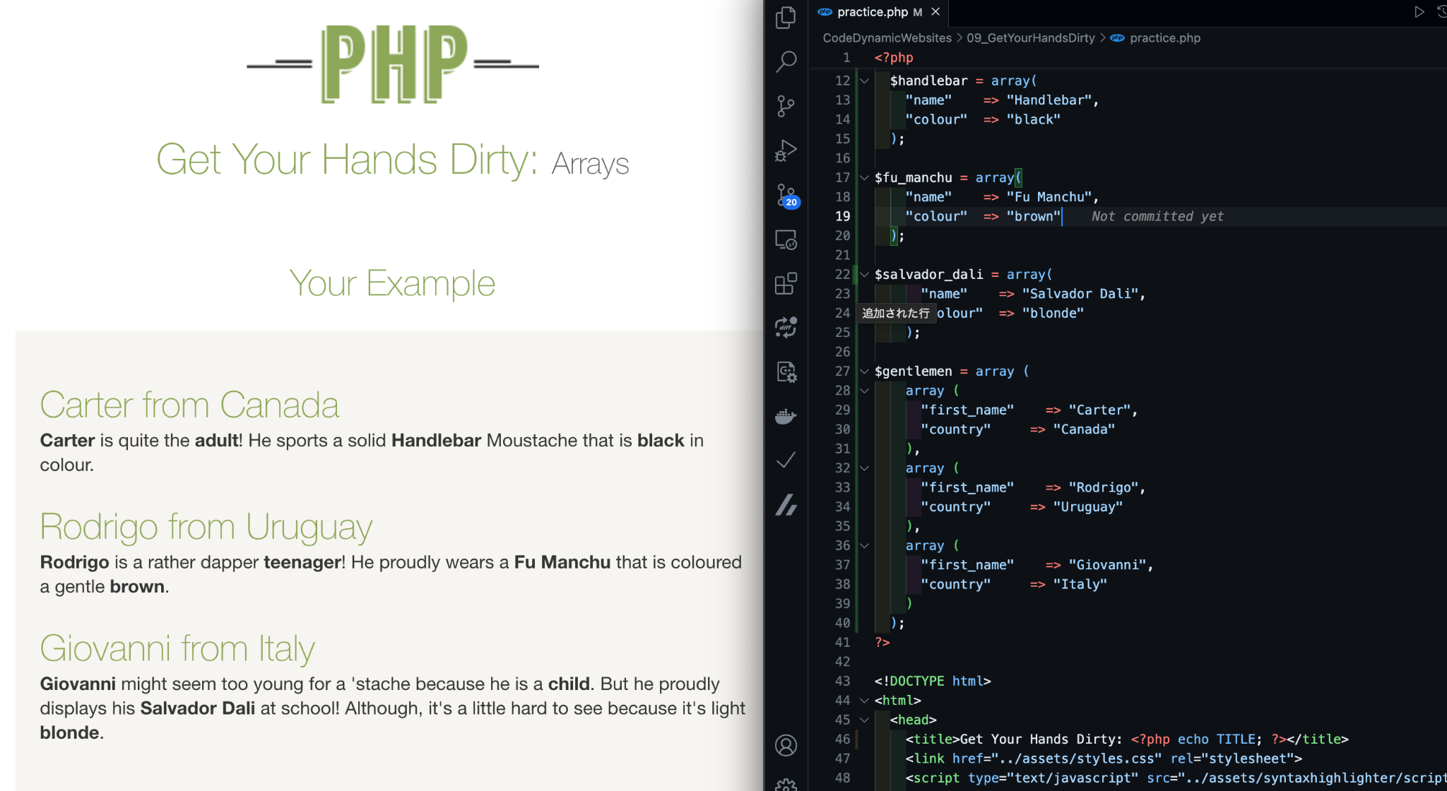

Figure 3-1. A screenshot showing that section 3 ‘PHP Arrays’ has been completed.

Word Count: 95

References

1. Brad Hussey, Code College. (n.d.). *Practical PHP: Master the Basics and Code Dynamic Websites.* Retrieved from https://www.udemy.com/course/code-dynamic-websites/